RIDE THE SLOPE
INTERDAY & SCALPING METHOD FOR FOREX
BY EMATRADER

POSTED ON
WWW.FOREXFACTORY.COM

Step 1:
Decide which pair you want to trade.
Step 2:
Open these TF: H4/H1/30M/15M/5M/1M
Step 3:
Select the time frame you want to trade (base chart). Add PP/M1/M2/S1/S2/R1/R2. Also, support and resistance levels on the 1 level higher TF. EX: your base is 30M Find areas where price have S/R levels on H1 chart.
Getting good results from scalping also depend on what time you enter in the trade. London open to 3PM EST is perfect time to use this system.
Base chart SL TP Confirmation Effectiveness
5M 10 10 1M **
15M 15 15 5M ***
30M 25 25 15M/5M *****
1H 35 40 30M/15M/5M *****
USD/JPY EUR/USD GBP/USD USD/CHF
Step 4:
The basic concept is the same as for long term (In the first document).
Add the same indicators on your chart.

An Example of a trade using 30M as base chart
2.0419 Entry 2.0444 SL and 2.0394 TP
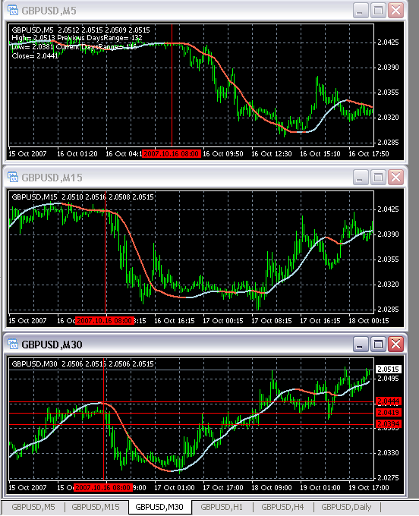

Another example where 30M shows an uptrend but 5M does not show it’s a good example where you should wait until 15M and 5M have an uptrend as well along 30M to enter for long.
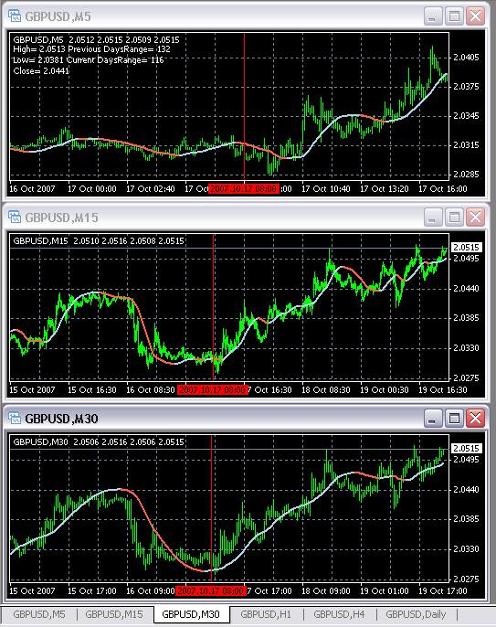
Here is the long entry at 11:15 GMT. All three have positive slope.

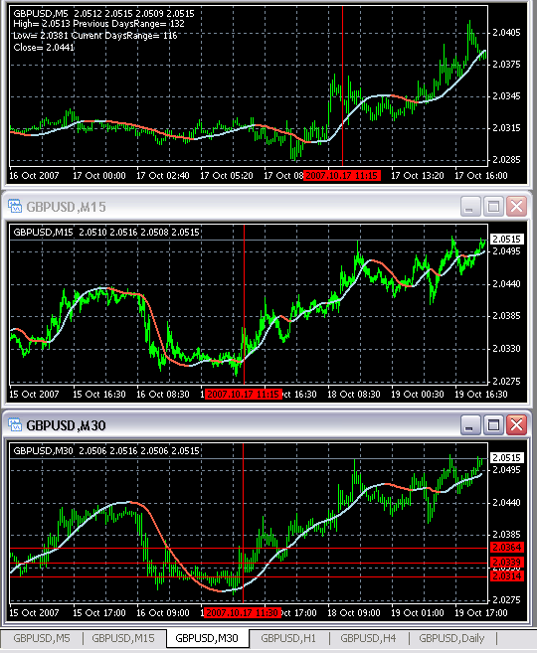
Now what if your base chart at 11:15 GMT on 2007-10-17 was 15M instead of 30M?

Long at 2.0339 SL 2.0319 and TP2.0359
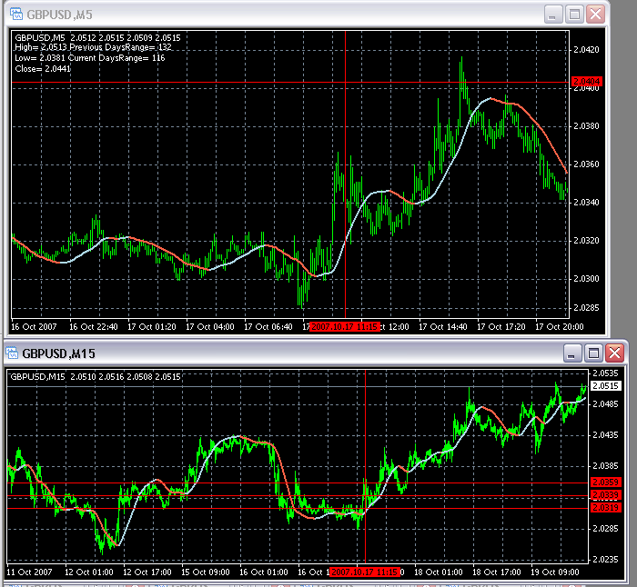
When you inter day trade from H1 (base chart) make sure to confirm the trend on H4 as well.
That’s all for now
Good Luck and happy trading.
EMATRADER

